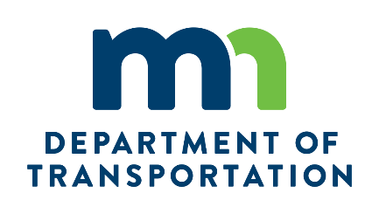

Highway 23 Road Connection Project (134th Avenue West)
Public Open House
May 30, 2019

COMMENT FORM

Name: ________________________________________________
Address: ________________________________________________
Phone: ________________________________________________

Comments:_____________________________________________________________________________________________________________________________________________________________________________________________________________________________________________________________________________________________________________________________________________________________________________________________________________________________________________________________________________________________________________________________________________________________________________________________________________________________________________________

